

|  |
| --- |
| **LAB 6** of DSA LAB |

**Submitted by:**

**Name:** Muhammad shuraim

**Roll no:** SU92-S24-BSSEM-103

**Section:** 3A

**Submitted to**

Sir Rasikh Ali

**Question 1**

#include <iostream>

using namespace std;

class Node {

public:

int value;

Node* next;

Node(int val) {

value = val;

next = nullptr;

}

};

class LinkedList {

public:

Node* head;

LinkedList() {

head = nullptr;

}

void insert_at_start(int val) {

Node* newnode = new Node(val);

newnode->next = head;

head = newnode;

}

void delete_at_start() {

if (head == nullptr) {

cout << "List is already empty.\n";

return;

}

Node* temp = head;

head = head->next;

delete temp;

}

void delete_at_end() {

if (head == nullptr) {

cout << "List is already empty.\n";

return;

}

if (head->next == nullptr) {

delete head;

head = nullptr;

return;

}

Node* temp = head;

while (temp->next->next != nullptr) {

temp = temp->next;

}

delete temp->next;

temp->next = nullptr;

}

void delete_nth_node(int n) {

if (head == nullptr) {

cout << "List is empty.\n";

return;

}

if (n == 1) {

delete_at_start();

return;

}

Node* temp = head;

for (int i = 1; temp != nullptr && i < n - 1; i++) {

temp = temp->next;

}

if (temp == nullptr || temp->next == nullptr) {

cout << "Invalid position!\n";

return;

}

Node* node_to_delete = temp->next;

temp->next = temp->next->next;

delete node_to_delete;

}

void delete_middle_node() {

if (head == nullptr || head->next == nullptr) {

delete_at_start();

return;

}

Node* turtle = head;

Node* tiger= head;

Node* prev = nullptr;

while (tiger != nullptr && tiger->next != nullptr) {

prev = turtle;

turtle = turtle->next;

tiger = tiger->next->next;

}

prev->next = turtle->next;

delete turtle;

}

void display() {

if (head == nullptr) {

cout << "LIST IS EMPTY\n";

return;

}

Node* temp = head;

while (temp != nullptr) {

cout << temp->value << " -> ";

temp = temp->next;

}

cout << "NULL\n";

}

};

int main() {

LinkedList list;

list.insert_at_start(10);

list.insert_at_start(20);

list.insert_at_start(30);

list.insert_at_start(40);

list.insert_at_start(50);

cout << "Original List: ";

list.display();

list.delete_at_start();

cout << "After deleting first node: ";

list.display();

list.delete_at_end();

cout << "After deleting last node: ";

list.display();

list.delete_nth_node(2);

cout << "After deleting 2nd node: ";

list.display();

list.delete_middle_node();

cout << "After deleting middle node: ";

list.display();

return 0;

}

**OUTPUT**

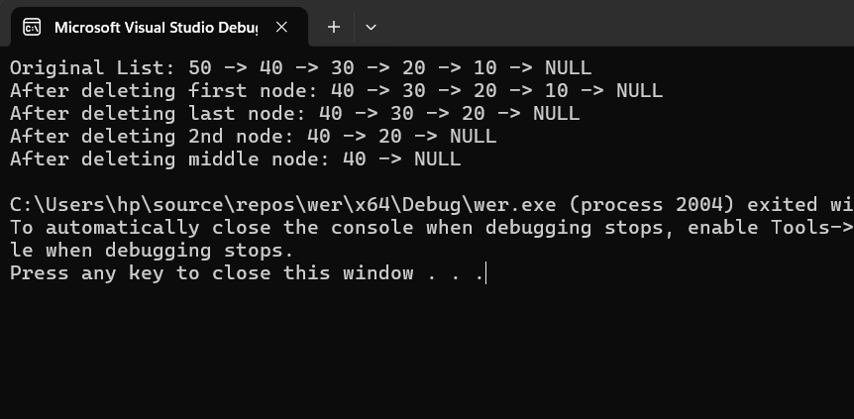

Explanation

* The `Node` class represents each node with a `value` and a pointer `next` to the next node.

**LinkedList Class:**

- **`insert_at_start(int val)`** → Adds a node at the beginning.

- **`delete_at_start()`** → Deletes the first node.

- **`delete_at_end()`** → Deletes the last node.

- **`delete_nth_node(int n)`** → Deletes the node at a given position `n`.

- **`delete_middle_node()`** → Deletes the middle node using the **tortoise and tiger** approach.

- **`display()`** → Prints the list.

**Main Function:**

1. Inserts values **50 → 40 → 30 → 20 → 10** into the list.

2. Performs deletions:

- Deletes the **first node**.

- Deletes the **last node**.

- Deletes the **2nd node**.

- Deletes the **middle node**.